Instructions for Viewing KMZ Files related to Nutrient Application Regulations using Google Earth Last Update: Spring 2013

- Download Google Earth (if you already have version 6 or more recent, skip to #2)
If you don’t already have Google Earth, you can download it free of charge at: earth.google.com
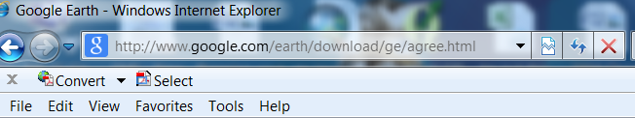

- Get a free account at the Manitoba Land Initiative (if you already have one, skip to #3)
If you don’t already have an account, go to the Manitoba Land Initiative website at http://mli2.gov.mb.ca//
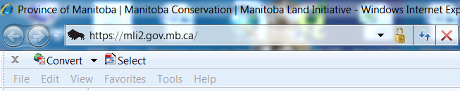

Scroll down until you see “Download Digital Maps”
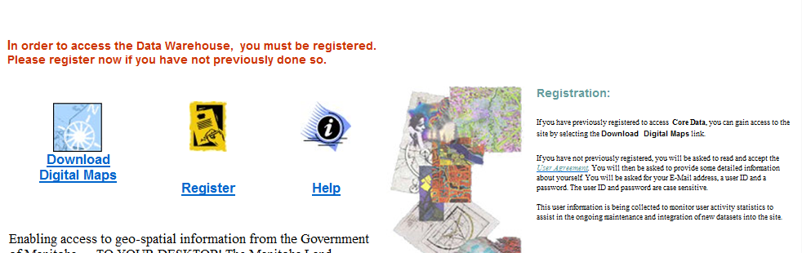

Double left click on “Register” to create a user name and password. Read the Terms and Conditions of Use and if you agree and want to proceed, double left click on “I have read and I AGREE”:

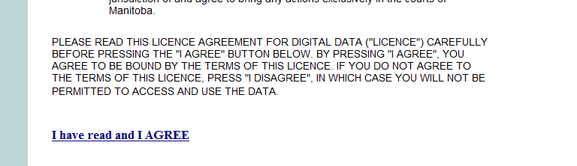

- Sign in to Download Digital Maps
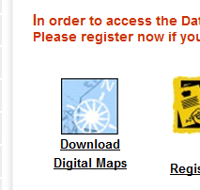
Go to the MLI website, scroll down and double left click on “Download Digital Maps”

You will be prompted to enter your user name and password. Enter both and press “OK”. This will bring you to the Core Maps Data Warehouse.
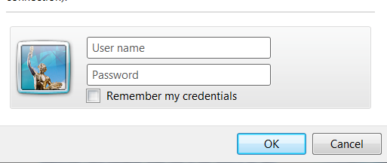

- Find KMZ files for your municipality

KMZ files are compatible with Google Earth.

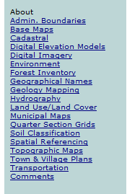
On the left hand column, you will find a list of folders that you can choose from. Move your curser over “Soil Classification” and double left click.

Move your curser over “Agricultural Interpretation Database (SoilAID)” and double-left click.

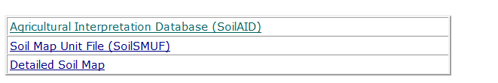
- Download the KMZ file associated with the Rural Municipality of interest

A table listing different KMZ downloads by Rural Municipality will be provided. The headings are listed at the top of the table as shown below.
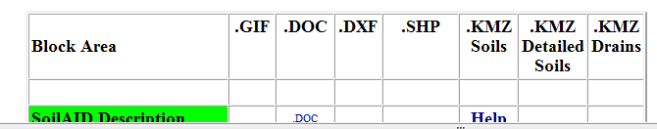
- Identify Soils

For example, if your area of interest is in La Broquerie, and you are interested in soils, double left click on the .KMZ Soils link on that row. (Note: Turtle Mountain, Springfield, Blanshard and Ritchot have recently been surveyed and newer more detailed soil survey information is available. The link in the column “KMZ Detailed Soils” for the respective RMs should be selected to obtain the reports).

You will be prompted to open or save the file. Double left click on “Open”.

A WinZip screen will pop up. Double left click on “Doc.kml”

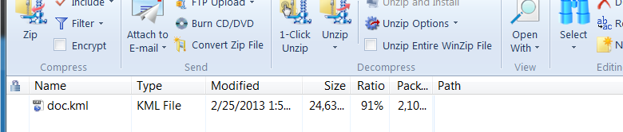

You will be prompted to open the file. Left click on “Open”. This should automatically open Google Earth for you and load your file. Now, you can move your curser over the polygon of interest and single left click to view soil information.

Use the tools in Google Earth on the right hand side of the screen to navigate
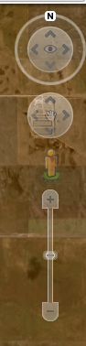

The tools will enable you to zoom, pan, and rotate the view. The street view function works well for some but not all areas.

Determine the dominant and subdominant agricultural capability ratings in a polygon
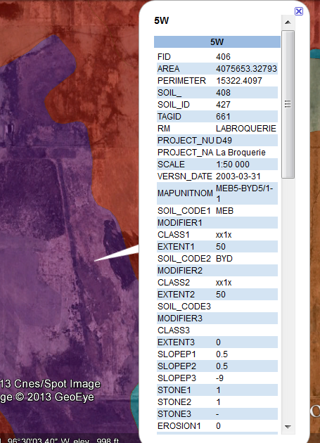
Left click on a polygon of interest to bring up information. You will observe several polygons with differing colours.
Polygons are coloured in accordance with the dominant agricultural capability soil class: 1=pink, 2=yellow, 3M=blue, 3 (excluding 3M)=brown, 4=red, 5=purple and 6=grey. This will give you a general overview of the area. However, for nutrient management planning, you need to know the subdominant soils as nutrients must be applied in accordance with the restrictions pertaining to the most limiting soil in a polygon..

Use the drag down bar on the side to view more information.
Note: Scale is provided as well as the number of the report. In this example, the information provided is from Report number D49 which is a detailed soils report at a scale of 1:50,000.

See Appendix 1 for details on how to interpret the data provided.

- Identify Drain Orders

Drain Orders area also available under the Soil Classification page.

On the left hand column, you will find a list of folders that you can choose from. Move your curser over “Soil Classification” and double left click.

Move your curser over “Agricultural Interpretation Database (SoilAID)” and double-left click. A table listing different KMZ downloads by Rural Municipality will be provided.

For example, if you area of interest is in La Broquerie, and you are interested in drains, double left click on the .KMZ Drain file in that row.

You will be prompted to open or save the file. Double left click on “Open”.

A WinZip screen will pop up.

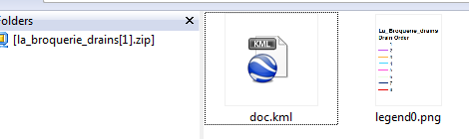

The png file on the right side of the above picture is the Drain Order legend. For information on Drain Orders, please see Appendix II.

Double left click on “Doc.kml”

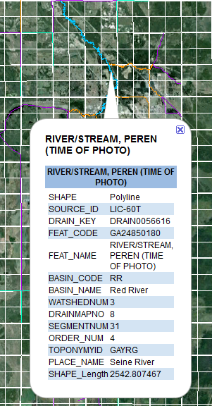
You will be prompted to open the file. Left click on “Open”. This should automatically open Google Earth for you and load your file. Now, you can move your curser over the drain of interest and single left click to view information. Setback requirements for application of nutrients on land depend on order of the adjacent drain.

In the example, a thick blue line, classified as a
Order 4 drain is selected. Names of rivers are provided; in this example the drain identified is the Seine River..
- Identify a Quarter Section of Interest

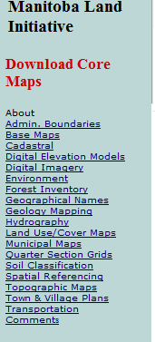

Using MLI and GoogleEarth, you can identify a particular legal location. Log on through “Download Digital Maps” on the MLI website and view the information on left column. Move your curser over “Quarter Section Grids” and double left click.

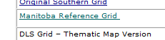
Move your curser over “Manitoba Reference Grid” and double left click.

You will see a partial map of Manitoba. You are going to be looking for KMZ files, therefore, move your curser over “KMZ” and double click.
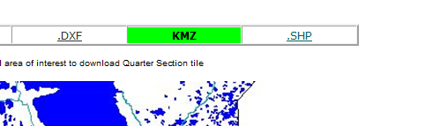

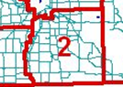
Put your curser over the area of interest in the province. For example, if you are looking for La Broquerie, move your curser over the area identified as “2” and double left click. You will be prompted to “Open” or “Save” the information.

By double clicking on “Open”, a WinZip screen will pop up. Double left click on “Doc.kml”

You will be prompted to open the file. Left click on “Open”. This should automatically open Google Earth for you and load your file.

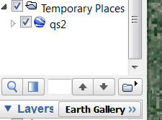
On the left column, under “Temporary Places”, move your curser over “qs2” and right click. Select “Properties” from the dropdown menu.

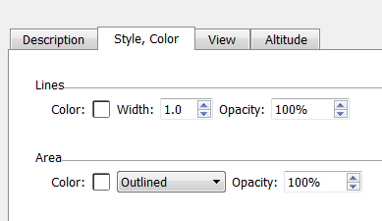

Select the “Style, Color” tab. You can change the line colour and area fill as you wish. Once you are satisfied, hit OK to save the changes and close the window.

Make sure ‘qs2’ is still on and selected under “Temporary Files” as shown below.

Now you should have an outline of quarter sections on your map. The navigation tools on the right hand side of the screen will enable you to zoom, pan, and rotate the view.

Left click inside a quarter section to determine the legal land location.

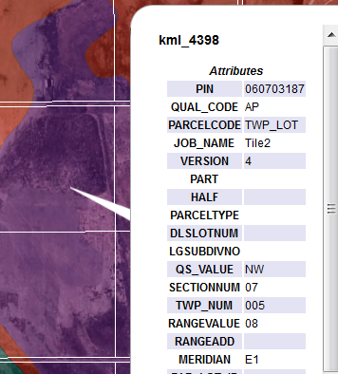
This example identifies the location as NW 07-05-08 EPM: Quarter (QS_Value) = NW, Section (Sectionnum) 07, Township (TWP_Num) 5, Range (RangeValue) 8, in Meridian (Meridian) E1.
You may wish to turn off the soil layer to see the underlying satellite imagery. You do this by left clicking on top of the check boxes to remove the checkmark.

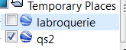

- Identify a River Lot of Interest

Log on through “Download Digital Maps” on the MLI website and view the information on left column. Move your curser over “Cadastral” and double left click.

Double left click on “Tabular selection”
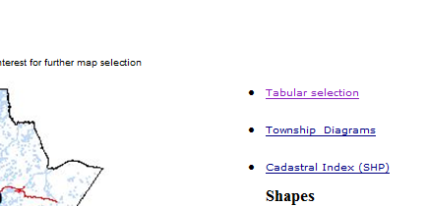
A list of available KMZ files is provided. Open and use the files with the methodology used for the quarter section grid.

- Identify an Administrative Boundary
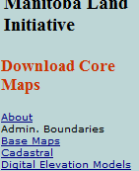The outline of the Red River Valley Special Management Area (RRVSMA) and the Township Grid are files that can be found by selecting the heading Admin Boundaries on the MLI. The Livestock Manure and Mortalities Management Regulation contains additional restrictions for fall application in the RRVSMA.

Appendix 1. Soils

The soil names corresponding to the 3 letter codes (for example, SOIL_CODE1: MEB, SOIL_CODE2: BYD) on the maps are described in the corresponding soils report, or at the following hyperlink to the Soil Descriptions document: http://www.gov.mb.ca/agriculture/land/soil-survey/importance-of-soil-survey-mb.html#detailed

http://www.gov.mb.ca/agriculture/land/soil-survey/pubs/description_of_soil_series_in_mb.pdf

Soil agricultural capability classification (which is associated with the corresponding ‘SOIL_CODE’) is provided in the rows called “Agri_Cap” 1-3. The proportion of each is provided in the line “ERSYMBOL”.
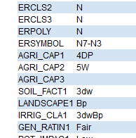
In this example, ERSYMBOL is N7-N3. This tells you that 70% of the soil is of one type (MEB) and the remainder 30% of soil in the polygon is another type (BYD). The first alpha-numeric symbol, N7, corresponds with AGRI_CAP1 and the second N3, corresponds with AGRI_CAP2. That is, 70% of the soil is classified as 4DP and 30% is 5W: the dominant soil is rated as 4DP and the subdominant soil is rated as 5W.

The below link describes the specific agricultural capability ratings and the different restrictions on annual crop productivity:
http://www.gov.mb.ca/agriculture/environment/soil-management/soil-management-guide/using-soil-survey-information.html#ag_capability

Appendix 1 provides some information on the soil mapping convention. For more information, you can view the actual reports on other websites such as:
http://res.agr.ca/cansis/publications/surveys/mb/index.html and
http://www.gov.mb.ca/agriculture/land/soil-survey/importance-of-soil-survey-mb.html
http://www.gov.mb.ca/agriculture/land/soil-survey/

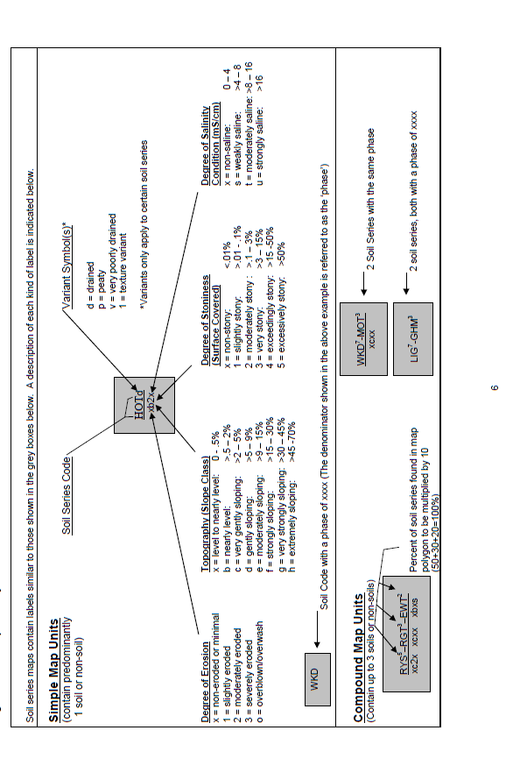
Appendix II. Drain Orders
The Strahler System is the drain order criteria used in Manitoba. In Manitoba, setback distances for application of manure are greater adjacent to drains with a Order 3 or greater designation than they are for Order 1 and 2 drains.

Stream and drain order criteria
Classification systems such as the Strahler System have been developed to rank streams/drains according to their relative position within the drainage system of a watershed.
In the Strahler system, the smallest headwater tributaries are called first-order streams. Where two first order streams join, a second-order stream is created; where two second-order streams join, a third-order stream is created; and so on.

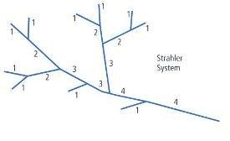

<<END>>

